2.1 Data Preparation
Analysis of combined_data.csv to investigate the classification of users.
2.1.1 Sample Selection
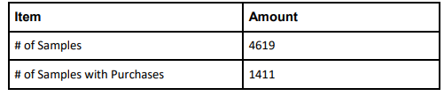

2.1.2 Attribute Creation
A new categorial attribute was created to enable analysis of players as broken into 2 categories (HighRollers and PennyPinchers). A screenshot of the attribute follows:
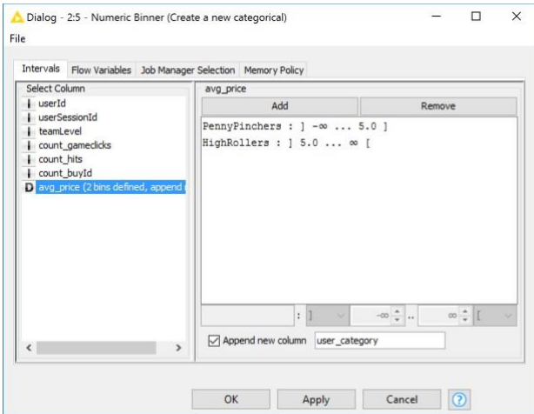

A new categorical attribute, named “user_category”, is created by the Numeric Binner node. As presented in the instruction, we need to define two categories for price which we will use to distinguish between HighRollers(buyers of items that cost more than $5.00) and PennyPinchers (buyers of items that cost $5.00 or less), so as we see in the screenshot above, the user who costs $5.00 or less is defined as “PennyPinchers”, the user who costs more than $5.00 is defined as “HighRollers”.
The creation of this new categorical attribute was necessary because it can facilitate the classification of users and contribute to the following steps.
2.1.3 Attribute Selection
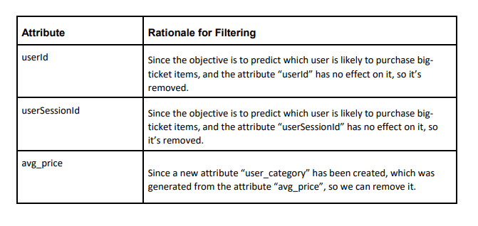
The following attributes were filtered from the dataset for the following reasons:

